A tour through the district | A tour through the district
A tour through the district | A tour through the district
A tour through the district | A tour through the district
A tour through the district | A tour through the district
A tour through the district | A tour through the district
A tour through the district | A tour through the district
A tour through the district | A tour through the district
A tour through the district | A tour through the district
A tour through the district | A tour through the district

START |  | cross | 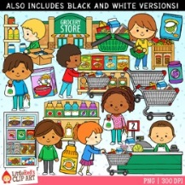
supermarket | 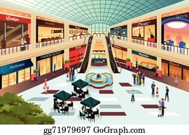 | shopping mall
pharmacy | 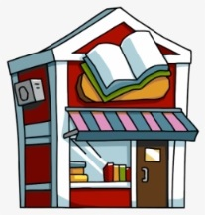 | book store | 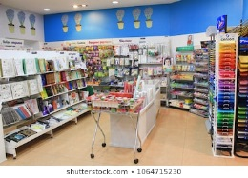
stationary store |  | go past | 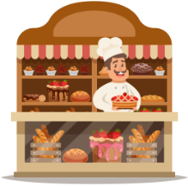
bakery | 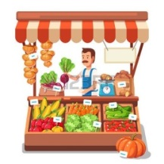 | fruit and vegetable stand | 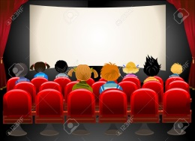
cinema | 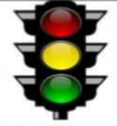 | traffic light
roundabout |  | sidewalk
zebra-crossing |  | crossroad | /
turn left/right |  | go straight ahead | End

